**PRACTICAL 11**

**Aim:**

Study the performance testing tests the non-functional requirements of the system. The different types of performance testing are load testing, stress testing, endurance testing and spike testing.

# Software Requirement: None

**Knowledge Requirement:** Performance Testing

# Theory:

Performance testing is the process of determining the speed, responsiveness and stability of a computer, network, software program or device under a workload. Performance testing can involve quantitative tests done in a lab or occur in the production environment in limited scenarios. Performance metrics commonly include:

Throughput: Number of units of information a system processes over a specified time. Memory: The working storage space available to a processor or workload.

Response time, or latency: The amount of time that elapses between a user-entered request and the start of a system's response to that request.

Bandwidth: The volume of data per second that can move between workloads, usually across a network. CPU interrupts per second: The number of hardware interrupts a process receives per second.

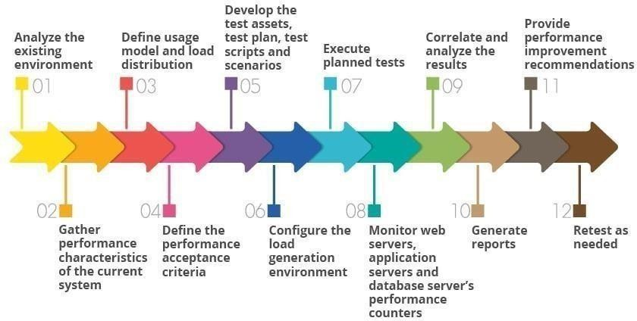

# Types of Performance Testing:

Load testing: Load testing measures system performance as the workload increases. That workload could mean concurrent users or transactions. The system is monitored to measure response time and system staying power as workload increases. That workload falls within the parameters of normal working conditions.

Stress Testing: Stress testing is also known as fatigue testing. It is meant to measure system performance outside of the parameters of normal working conditions. The software is given more users or transactions that can be handled. The goal of stress testing is to measure the software stability.

Spike Testing: Spike testing is a type of stress testing that evaluates software performance when workloads are substantially increased quickly and repeatedly. The workload is beyond normal expectations for short amounts of time.

Endurance testing: Endurance testing is also known as soak testing. It is an evaluation of how software performs with a normal workload over an extended amount of time. The goal of endurance testing is to check for system problems such as memory leaks.

# Problem Description:

Identify the type of performance testing for the following:

1. A university uses its web-based portal for publishing the results of the students. When the results of an examination were announced on the website recently on apre-planned date, the web site crashed. Which type of performance testing should have been done during web-site development to avoid this Unpleasant situation?

**Ans:** Stress Testing

1. A space craft is expected to function for nearly 8 years in space. The orbit control system of the spacecraft is a real-time embedded system. Before the launch, the embedded software is to be tested to ensure that it is capable of working for 8 years in the space. Identify the suitable performance testing category to be carried out to ensure that the space craft will be functioning for 8 years in the space as required.

**Ans:** Endurance Testing

1. During unexpected terrorist attack, one of the popular websites crashed as many people logged into the website in a short span of time to know the consequences of terrorist attack and for immediate guidelines from the security personnel. After analysing the situation, the maintenance team of that website came to know that it was the consequences of unexpected load on the system which had never happened previously. Which type of performance testing should have been done during web-site development to avoid this unpleasant situation?

**Ans:** Spike Testing

1. Global Education Centre (GEC) at Infosys Mysore provides the training for fresh entrants. GEC uses an automated tool for conducting objective type test for the trainees. At a time, a maximum of 2000 trainees are expected to take the test. Before the tool is deployed, testing of the tool was carried out to ensure that it is capable of supporting 2000 simultaneous users. Indicate the performance testing category?

**Ans:** Load Testing